RIBBON BURNERS GROUP P-1 Air-Gas
RANGE: CRB

Introduction
This industry standard all stainless steel linear flame burner is compact, robust and light weight. It is a versatile general purpose air gas burner designed for applications which require a continuous and evenly balanced flame using Natural gas or LPG with air.

Specification
50 – 500 mm flame length.
Standard design 3 and 4 rows ports. Ignition / flame sense electrodes are available fitted options with complete automatic control panels.
See data sheets V-2, V-3
Compressed air- gas mixer required as minimum control equipment for correct operation. See data sheets J-1, J-4.

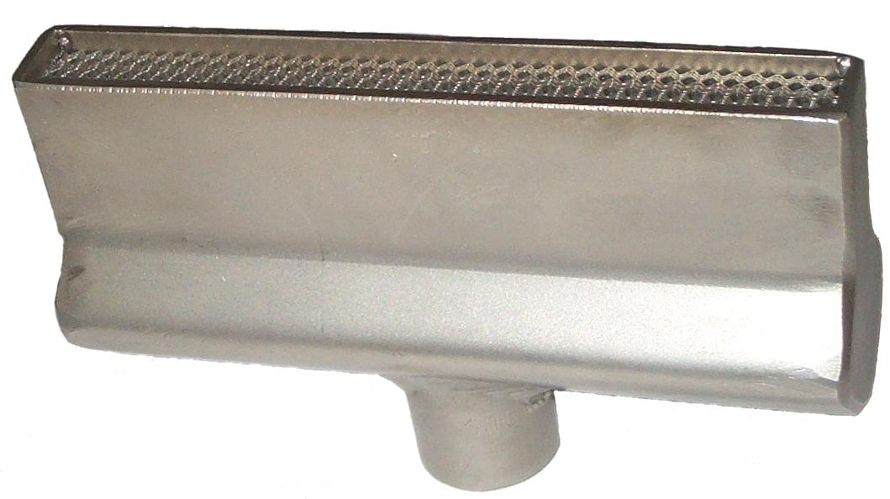

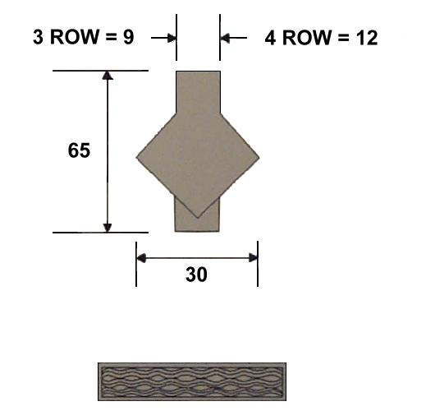

Applications
Flame Plasma surface treatment of plastic containers, cable and pipe prior to printing and coating. Edge melting and forming of glass tubing, plate and table ware.
Heating of wire and metal sections for heat treatment, forming and metal joining.

3 ROW
Cat.No. Type. Flame Kcal/hr. Inlet
Length nominal Size
P100 CRB3-50 50 2500 3/8”BSP
P101 CRB3-75 75 3750 3/8”BSP
P102 CRB3-100 100 5000 3/8”BSP
P103 CRB3-150 150 7500 3/8”BSP
P104 CRB3-200 200 10000 ½” BSP
P105 CRB3-250 250 12500 ½” BSP
P106 CRB3-300 300 15000 ½” BSP
P107 CRB3-350 350 17500 ½” BSP
P108 CRB3-400 400 20000 ½” BSP
P109 CRB3-450 450 22500 ½” BSP
P110 CRB3-500 500 25000 ½” BSP
4 ROW
P115 CRB4-50 50 3000 3/8”BSP
P116 CRB4-75 75 4500 3/8”BSP
P117 CRB4-100 100 6000 3/8”BSP
P118 CRB4-150 150 9000 ½” BSP
P119 CRB4-200 200 12000 ½” BSP
P120 CRB4-250 250 15000 ½” BSP
P121 CRB4-300 300 18000 ½” BSP
P122 CRB4-350 350 21000 ½” BSP
P123 CRB4-400 400 24000 ½” BSP
P124 CRB4-450 450 27000 ½” BSP
P125 CRB4-500 500 30000 ½” BSP
Mounting brackets for ignition and flame monitoring electrodes are available to specification.

